8. employee last name and project name for employees who have at least one dependent and work on a project at least 17 hours

select e.lname, p.pname

from employee e, project p, works_on w

where e.ssn = w.essn

and p.pnumber = w.pno

and w.hours >= 17

and e.ssn in (select distinct essn from dependent);

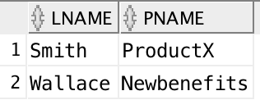

9. employee last names for employees who do not work on any projects.

select lname

from employee

where ssn not in

(select essn from works_on

where employee.ssn = works_on.essn);

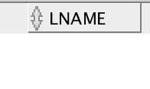

10. employee last names who have a child the same sex as they are.

select lname

from employee

where ssn in

(select essn from dependent

where employee.ssn = dependent.essn

and employee.sex = dependent.sex

and (relationship = 'Son' or relationship = 'Daughter'));

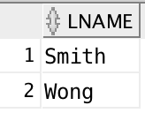

11. employee last names for employees who do not have a child of the same sex as themselves.

select lname

from employee

where ssn not in

(select essn from dependent

where employee.ssn = dependent.essn

and employee.sex = dependent.sex

and (relationship = 'Son' or relationship = 'Daughter'));

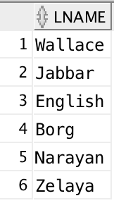

(a) Retrieve the names of employees in department 5 who work more than 10 hours per week on the 'ProductX' project.

select e.fname, e.minit, e.lname

from employee e, works_on w, project p

where e.ssn = w.essn and w.pno = p.pnumber

and e.dno = 5 and w.hours > 10 and p.pname = 'ProductX';

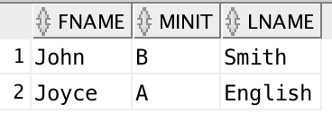

(b) List the names of employees who have a dependent with the same first name as themselves.

select e.fname, e.minit, e.lname

from employee e, dependent d

where e.ssn = d.essn

and e.fname = d.dependent_name;



(c) Find the names of employees who are directly supervised by 'Franklin Wong'.

select fname, minit, lname

from employee

where super_ssn =

(select ssn from employee

where fname = 'Franklin' and Lname = 'Wong');

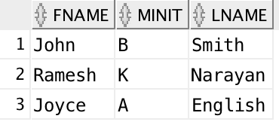

(d) For each project, list the project name and the total hours per week (by all employees) spent on that project.

select p.pname, sum(w.hours) as total_hours

from project p, works_on w

where p.pnumber = w.pno

group by p.pname;

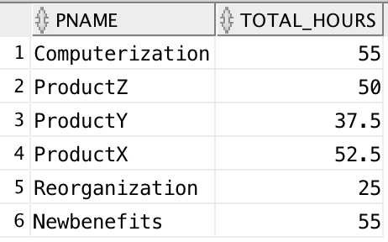

(e) Retrieve the names of employees who work on every project.

select e.fname, e.minit, e.lname

from employee e, works_on w

where e.ssn = w.essn

group by e.fname, e.minit, e.lname, e.ssn

having count(distinct(w.pno)) =

(select count(distinct pnumber) from project);

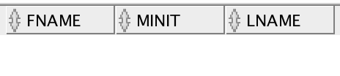

(f) Retrieve the names of employees who do not work on any project.

select e.fname, e.minit, e.lname

from employee e

where not exists

(select * from works_on where essn = e.ssn);

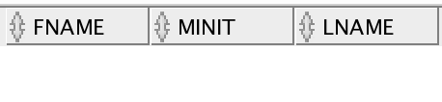

(g) For each department, retrieve the department name, and the average salary of employees working in that department.

select d.dname, avg(salary) as average_salary

from department d, employee e

where d.dnumber = e.dno

group by d.dname;

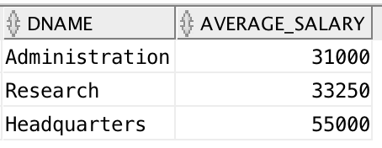

(h) Retrieve the average salary of all female employees.

select avg(salary) as average_f_salary

from employee

where sex = 'F';

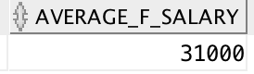

(i) Find the names and addresses of employees who work on at least one project located in Houston but whose department has no location in Houston.

select e.fname, e.minit, e.lname, e.ssn

from employee e

where e.dno not in

(select dnumber

from dept_locations

where dlocation = 'Houston')

and ssn in

(select essn

from works_on, project

where pno = pnumber

and plocation = 'Houston');

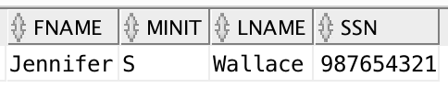

(j) List the last names of department managers who have no dependents.

SELECT e.lname

FROM employee e

WHERE EXISTS (SELECT * FROM department WHERE mgr_ssn = e.ssn)

AND NOT EXISTS (SELECT * FROM dependent WHERE essn = e.ssn);

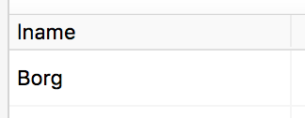

(k) Retrieve the names of all employees who work in the department that has the employee

with the highest salary among all employees.

select fname, minit, lname

from employee

where dno =

(select dno

from employee

where salary =

(select max(salary)

from employee));

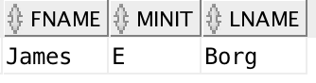

(l) Retrieve the names of all employees whose supervisor’s supervisor has '888665555' for

Ssn.

SELECT e.fname, e.minit, e.lname

FROM employee e

WHERE EXISTS (

SELECT *

FROM employee super

WHERE super.ssn = e.super_ssn

AND super.super_ssn = 888665555

);

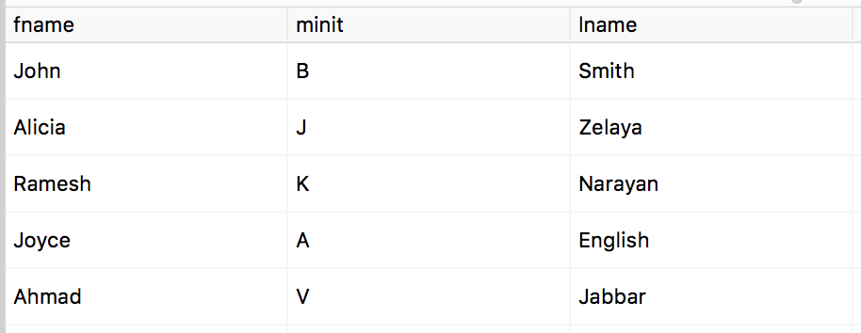

(m) Retrieve the names of employees who make at least $10,000 more than the employee

who is paid the least in the company

select fname, minit, lname

from employee

where salary >=

(select (min(salary) + 10000)

from employee);

